**Milestone 4 Results**

**Transient Spice Analysis:**

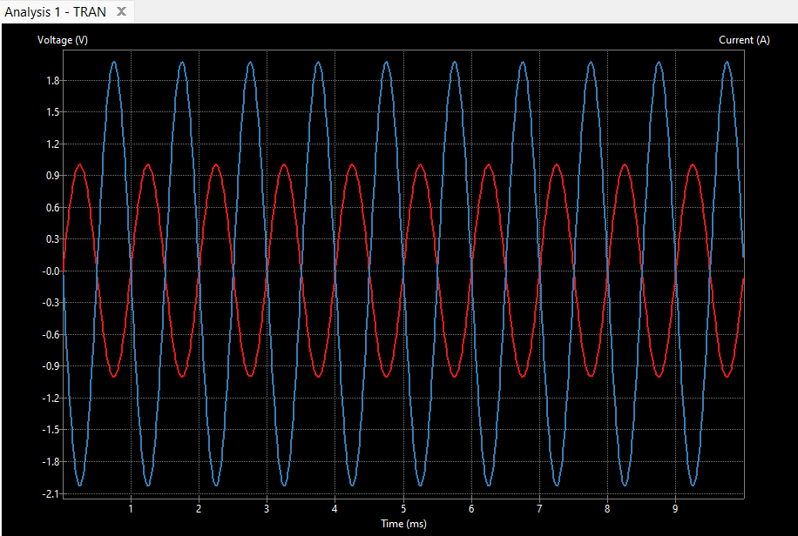

**Explanation and Expected Result:**

We developed an op-amp circuit with an voltage input of a 1 Volt sinusoidal signal. Because the feedback resistor had a magnitude 2 times that of the input resistor the output voltage is 2 times that of the input voltage. The output voltage is also inverted by the ability of an op amp to amplify the difference between the voltages at its two inputs: the non-inverting terminal (+) and the inverting terminal (−). Seen in the graph the difference in voltages from Vout and Vin is always at the, maximum possible. These results were expected and using the gain equation of an amplifier we can predict Vout when we know the value of Vin.

**AC Small Signal Analysis:**

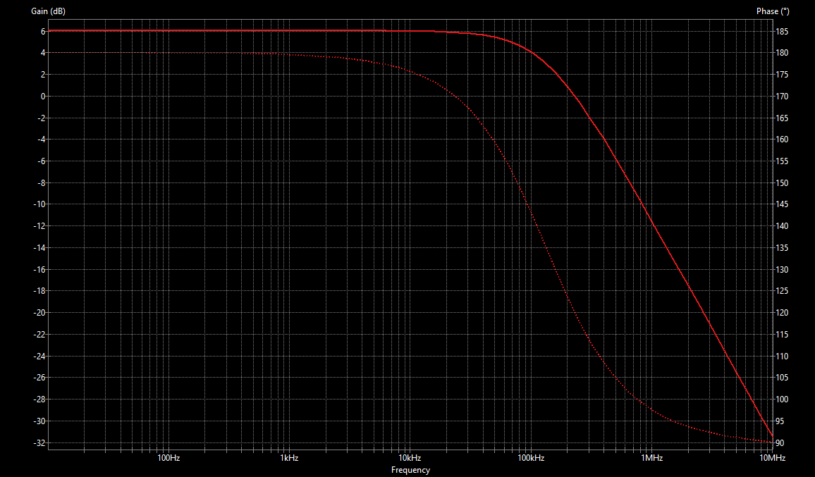

**Explanation and Expected Results:**

In the graph you can see both the gain (bold line) and phase (dashed line) falls off as frequency gets higher. This was expected from theory we know, take the gain to be A, in our circuit A = -2. To calculate, Vout = A*Vpeaksin(⍵t) as omega or essentially the frequency of our signal increases and Vout will diminish. The output voltage decreases with increasing frequency primarily due to the limited bandwidth and gain roll-off characteristics of the op-amp. You can also identify the cutoff frequency which is where the gain drops to 70.7% of its maximum value, this is where the max gain is -3dB. In this circuit the cutoff frequency is at 3dB since the gain started at 6dB, the frequency is 100kHz. As for phase it is also seen in the graph that it decreases in the higher frequency range. This is due to the feedback mechanism and internal capacitances of an op-amp. As the frequency increases, the feedback begins to change, leading to a more complex interaction between the input and output signals. The internal capacitances (such as input capacitance and output capacitance) become significant at higher frequencies. These capacitances introduce additional phase shifts.